**Did you Know?**

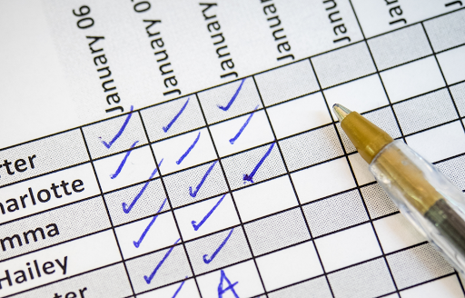

[This Photo](https://drzreflects.blogspot.com/2021/01/taking-attendance-during-zoom-class.html) by Unknown Author is licensed under [CC BY](https://creativecommons.org/licenses/by/3.0/)

**Regular attendance is a key factor in a child's academic success. Regular attendance is defined as a student attending more than 95% of the academic school year; this may include up to 8 absences (no more than 48 periods) in a 180-day school year. Chronic absenteeism is defined as any student that misses 15 or more school days (excused or unexcused). Excessive absences not only cause poor academic and health outcomes, but may also result in revocation of School Choice, suspension of a student's driver's license, or judicial action against the student's parents/guardians.**

**In the 2023-2024 school year Deerlake ‘s average daily attendance rate was 92.57% and the chronic absentee rate was 18%. Our 2024-2025 goal is to increase the average daily student attendance to 93% in 2024-2025 while reducing the number of chronically absent students to 15% or less. Our long term goal is to achieve an average daily attendance rate of 95% by the 2026-2027 school year while reducing the number of chronically absent students below 10%.**

**How Parents Can Encourage Good Attendance Habits**

**1-Help your child plan to arrive on time. Organize clothing and backpacks the night before. Be sure your student has set an alarm to wake up on time as well as an alarm on the time to depart home to account for transportation time (arrive at bus stop, walking to school, or traffic for those dropped off).**

**2-Schedule appointments to maximize time in class. We understand there are times when it is necessary to make appointments during the school day. Early morning or late afternoon appointments may help your child to be counted as “Present” which is defined as attending at least 4 periods of the school day. Consider the feasibility of returning your student to school after routine appointments such as orthodontic visits, to foster good attendance habits.**

**3-Report absences in a timely manner. Parents must upload an excusal note into the FOCUS portal or send in a hard copy to the main office within 24 hours of the absence. Deerlake does not accept phone calls, emails, nor Remind messages to excuse attendance. Should your child have an extended illness or medical emergency, please contact our Attendance Office so we may create a support plan to keep up with classwork. Please see the uploaded instructions for entering absences in FOCUS and forms to submit for planned/pre-excused absences.**